HOW TO UNLOCK THE GRADIENT MESH TOOL IN INKSCAPE
Aaron Nieze | August 17, 2015 |
http://goinkscape.com/how-to-unlock-the-gradient-mesh-tool-in-inkscape/
Gradient Meshes have been hiding in Inkscape 0.91 this whole time! Since it’s not a fully supported and stable feature, I’m assuming the developers hid the Gradient Mesh tool for the stable release of Inkscape. In this little tutorial, I’ll show you how to unlock and use gradient meshes in Inkscape!

STEP 1
Get Inkscape 0.91 opened up and go to Edit > Preferences. In the left pane, expand Interfaceand select Keyboard Shortcuts.
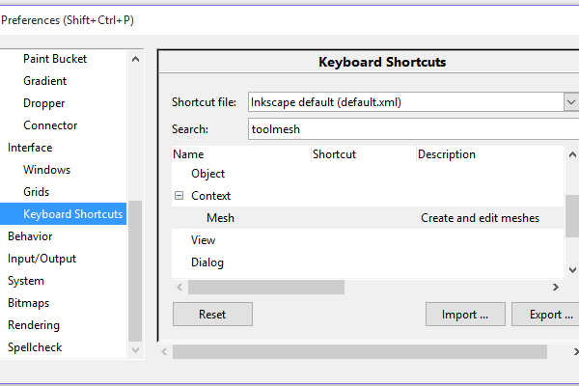

STEP 2
In the Search bar, type “toolmesh“, then expand Context to show Mesh. Now just click the empty Shortcut space next to Mesh so that it prompts “New accelerator”, which you can then choose a keyboard shortcut. I ended up using Ctrl+Alt+M because it just makes sense, but you can close the Preferences window now.
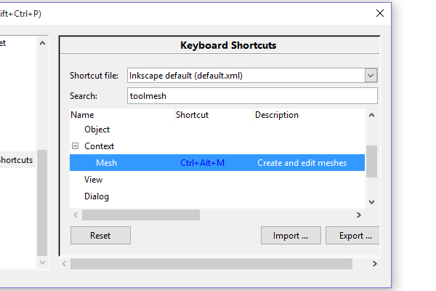

STEP 3
When the time comes where you need a gradient mesh, hit your keyboard shortcut (Ctrl+Alt+M) and double click on an object to create the mesh.
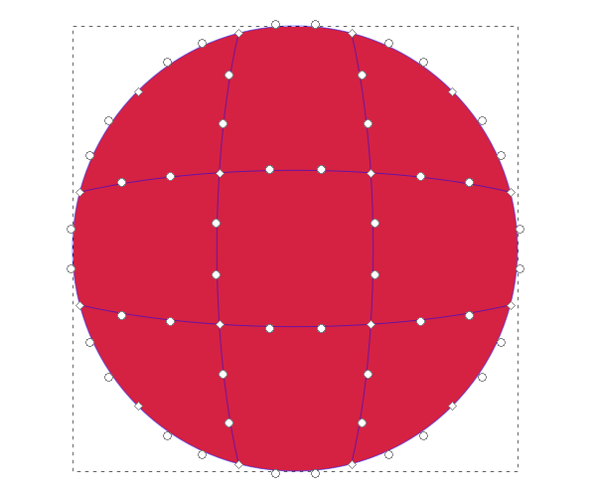

STEP 4
Now you can do cool stuff like this!


WHY WAIT?
Gradient meshes in Inkscape have been sought after by users for years, but the fact is they’ve been around the whole time. You can try some of Inkscape’s unstable builds that actually have the Gradient Mesh tool integrated, but you of course risk instability. Using this keyboard shortcut method is a great way to keep your stable version of Inkscape and also give gradient meshes a try. Some people say that it may be unstable even though Inkscape 0.91 is considered stable, but I have yet to encounter issues. Use this at your own risk and have fun
A big thank you goes to a reader named Bart for bringing this link to my attention.

